Assessment Schedule – 2014
Mathematics and Statistics: Apply algebraic methods in solving problems (91261)
Evidence Statement
One | Expected Coverage | Achievement (u) | Merit (r) | Excellence (t)
(a)(i) | 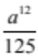 | Correct.
(ii) | 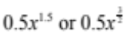 | Correct equivalent.
(iii) | 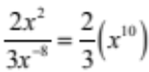 | Numerator or denominator correct. | Correct expression.
(b) | Let the roots be n and 3n.  3n² = 12  n² = 4  n = ±2  4n = ±m  m = ±8 | Relationship shown. | Values of n found. | Values of m found.
(c) | 3x² – nx + 5 = 0  For 2 solutions  n² – 4 × 3 × 5 > 0  n² > 60  n > 7.7 or n < –7.7 | Discriminant given. | One value of n found. | Both parts of inequality given.
(d) | (5x² – 4)(2x² – 1)  x² = 0.8 or 0.5  x = ±0.894 or ±0.707 | Expression factorised. | Solved for x². | All solutions given.

NØ | N1 | N2 | A3 | A4 | M5 | M6 | E7 | E8
No response; no relevant evidence. | Attempt at one question | 1 of u | 2 of u | 3 of u | 1 of r | 2 of r | 1 of t | 2 of t

Two | Expected Coverage | Achievement (u) | Merit (r) | Excellence (t)
(a)(i) | (3a – 5)(4a + 3)  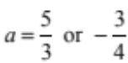 | Correct factorising or solution. | Correct solution showing factorisation.
(b)(i) | 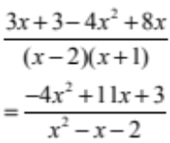 | Correct single fraction | Correctly simplified.  Accept with denominator in factorised form.
(ii) | 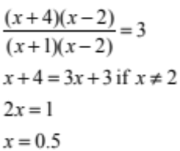 | Factorised and simplified  CAO. | Solved for x. | Condition x ≠ 2.
(c)(i) | rx² – tx – h = 0  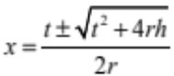 |  | Answer with ± before surd.
(ii) | 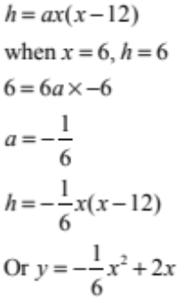 | General form of equation and recognition of point  (6,6). | Correct equation.
(iii) | 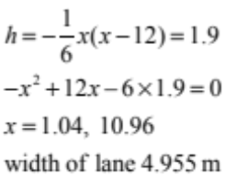 |  | Solved for height of 1.9 m. | Correct width of lane found.

NØ | N1 | N2 | A3 | A4 | M5 | M6 | E7 | E8
No response; no relevant evidence. | Attempt at one question | 1 of u | 2 of u | 3 of u | 1 of r | 2 of r | 1 of t | 2 of t

Three | Expected Coverage | Achievement (u) | Merit (r) | Excellence (t)
(a)(i) | 3^{x} = 81  x = 4 | Correctly solved.
(ii) | 343 = x³  x = 7 | Correctly solved.
(b) | 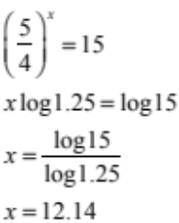 | Expression simplified. | Written in log form. | x found.
(c)(i) | 0.8 is the fraction of medication remaining after an hour. | Correct explanation.
(ii) | 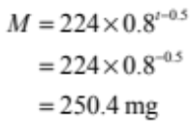 | Statement with t = 0 and attempt to solve. | Correctly solved.
(iii) | 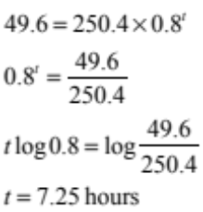 | M = 49.6 recognised and attempt to solve. | Correctly used logs in attempt to solve | Correctly solved.

NØ | N1 | N2 | A3 | A4 | M5 | M6 | E7 | E8
No response; no relevant evidence. | Attempt at one question | 1 of u | 2 of u | 3 of u | 1 of r | 2 of r | 1 of t | 2 of t

Cut Scores
 | Not Achieved | Achievement | Achievement with Merit | Achievement with Excellence
Score range | 0 – 8 | 9 – 14 | 15 – 18 | 19 – 24

